Online Bookstore – Analysis & Design Documentation

# 1. Project Overview

Goal: Build an e-commerce platform for buying books online. Users can browse, search, and view book details, register/login, add books to a cart, and checkout. Admins can manage books, categories, authors, users, and orders.  
  
Technology Stack:  
- Frontend: HTML, CSS, JavaScript  
- Backend: Django  
- Database: SQL (MySQL/PostgreSQL/SQLite)  
- Optional: Django REST Framework

# 2. Requirements

Functional Requirements:  
- Public Pages (Home, Categories, Books, Search)  
- User Accounts (Register, Login, Profile, Orders)  
- Cart & Checkout  
- Payment Integration (optional)  
- Admin Management (Books, Categories, Orders, Users)  
  
Non-Functional Requirements:  
- Secure  
- Scalable  
- Responsive  
- Maintainable  
- Fast

# 3. High-Level Architecture

Browser (HTML/CSS/JS) <--> Django Backend <--> SQL Database  
Static assets served via Django or CDN.  
Authentication and sessions handled by Django.

# 4. Data Model (ER Summary)

Entities:  
- User  
- Book  
- Category  
- Cart  
- Order  
- OrderItem  
- Review

# 5. Database Schema (Sample Tables)

- users_user (id, username, email, password)  
- books_category (id, name, slug)  
- books_book (id, category_id, title, author, price, stock)  
- cart_cart (id, user_id)  
- cart_cartitem (id, cart_id, book_id, qty)  
- orders_order (id, user_id, total_amount, status)  
- orders_orderitem (id, order_id, book_id, qty, price)  
- reviews_review (id, user_id, book_id, rating, comment)

# 6. Django Design

Models:  
- Category (name, slug)  
- Book (title, author, ISBN, price, stock, description, cover_image)  
- Order (user, total_amount, status)  
  
Views/URLs:  
- / → Home  
- /books/ → Book list  
- /books/<id>/ → Book detail  
- /cart/ → Cart  
- /checkout/ → Checkout  
- /orders/ → Order history  
- /admin/ → Admin dashboard

# 7. Frontend (HTML/CSS/JS)

Template hierarchy:  
- base.html (header, footer, nav)  
- home.html (featured books, categories)  
- book_list.html (list with filters)  
- book_detail.html (book info + add to cart)  
- cart.html (cart items, total)  
- checkout.html (address, payment)  
- account.html (user profile, orders)  
  
Responsive design using CSS/JS for interactivity.

# ER Diagram

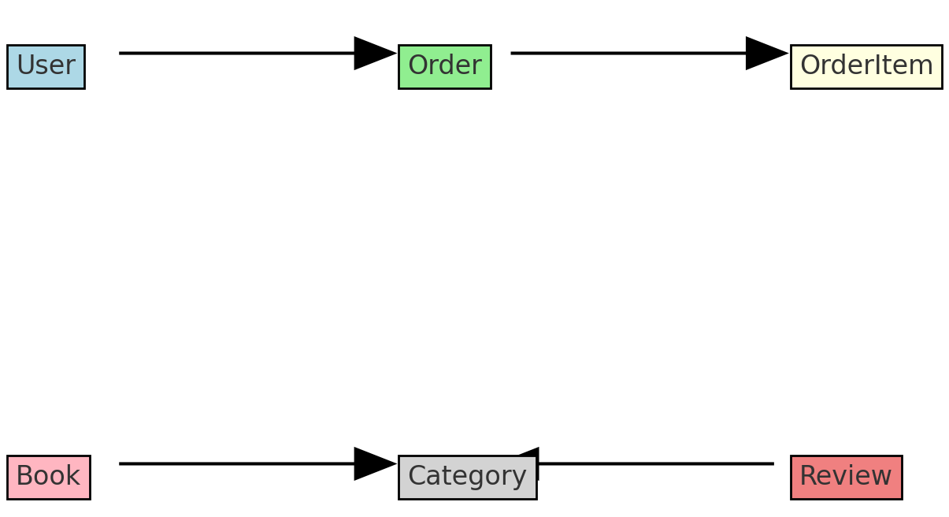

# High-Level Architecture Diagram

